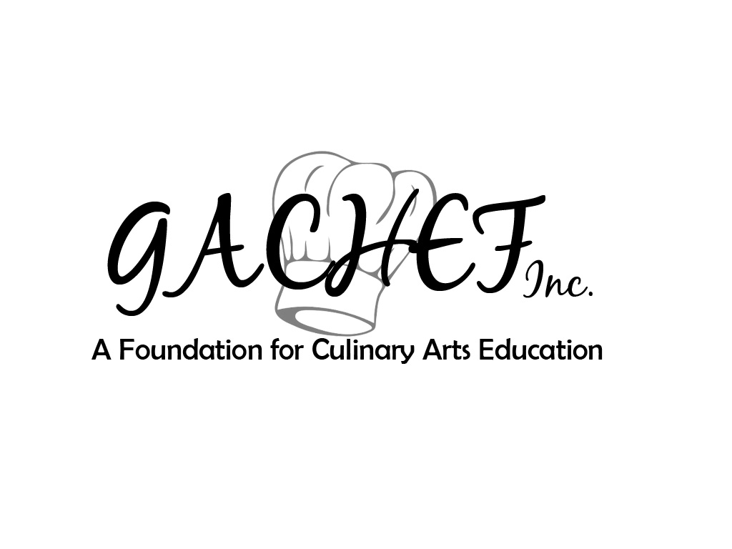

CULINARY ARTS
Industry Certification

Annual Report

The Culinary Arts Industry Certification Review is conducted y GACHEF Inc: A Foundation for Culinary Arts Foundation and ACF: American Culinary Federation. GACHEF is comprised of culinary arts related professionals from business/industry, post-secondary institutions/secondary institutions, representatives from the Georgia Department of Education and Georgia FCCLA.

Annual Reports and Recertification

- An Annual Report Form should be completed each year by May 15th. Major changes in the program may require additional follow-up.

- Schools that do not maintain standards for Industry Certification, including the areas monitored in this report, may be placed on probation, and receive a needs improvement plan. Schools that fail to maintain the standards for industry certification will lose their certification status and must re-apply for certification when applicable.

- Certified programs may recertify every five years and requires the same Site Visit procedures as the initial certification – review of the high school program.

CONTACT INFORMATION FOR GACHEF Inc.: A Foundation for Culinary Arts Education
Debra Stevens, GACHEF Director
3310 Grantham Road
Jesup, GA 31546
Dstevens7254@gmail.com
912-294-4369

(Year) Annual Report
(Will be completed the years following certification)
Industry Certification for Culinary Arts Programs

Each school is required to complete an annual report for ACFEF, in addition to the following document for GACHEF. This document must be submitted to GACHEF by May 15th.

- SCHOOL INFORMATION

School Name |  | School Enrollment
CTAE Director’s Name |  | School Phone Number
CA Phone Number |  | CA Fax Number
School Mailing Address
School Website Address |  | Year Program was First Certified

- PROGRAM INFORMATION

Culinary Arts Course Offerings

List the enrollment for each course in the pathway:
COURSE NAME | INSTRUCTOR | ENROLLMENT  MALE FEMALE

- ADVISORY COMMITTEE

- Date of Fall Advisory Committee Meeting
- Date of Spring Advisory Committee Meeting
- Please attach copies of advisory committee meeting minutes. Include members present at each meeting.

- Please list the names of all members of your Local Advisory Committee and indicate the business/organization he/she represents. Instructors and local school administrators should not be included.

MEMBER NAME | BUSINESS/ORGANIZATION REPRESENTED

- SUCCESS
Describe at least one success that has taken place this school year; for example, changes in the organization and administration of your program/department-such as adding a program, staff member, etc.

Describe at least one goal that you have set to improve the program and how you have or are accomplishing it.

- ENROLLMENT
Describe your enrollment in the high school program.

Include information such as increases/decreases in enrollment/recruitment/placement.

- INSTRUCTOR INFORMATION

High School Culinary Arts Teacher A
Name:
Email Address:
Years Teaching ___________ Does the instructor plan to return next school year?
Other responsibilities (FCCLA, Dept. Chair, Coach etc.):
Business-Related Professional Organization Memberships:
ORGANIZATION NAME | MEMBERSHIP NUMBER

Professional Development:
DATE | CONTACT  HRS | TITLE OF EVENT | SPECIFIC CULINARY RELATED ACTIVITY –  i.e. workshops/sessions attended

High School Culinary Arts Teacher B (if applicable)
Name:
Email Address:
Years Teaching ___________ Does the instructor plan to return the next school year?
Other responsibilities (FCCLA, Dept. Chair, Coach etc.):
Business-Related Professional Organization Memberships:
ORGANIZATION NAME | MEMBERSHIP NUMBER

Professional Development:
DATE | CONTACT  HRS | TITLE OF EVENT | SPECIFIC CULINARY RELATED ACTIVITY –  i.e. workshops/sessions attended

Is (Are) the above-mentioned high school Culinary Arts teacher(s) new? If so, please attach the following:
- Copy of his/her teaching certificate
- Business-Related Professional Organization Memberships with Member Number
- Professional Development Certificates for Current School Year
- ServSafe Manager Certification

- STUDENT CERTIFICATION/ASSESSMENT/FOLLOW-UP
Number of students receiving ServSafe Handler certificates this year:

Number of students receiving ServSafe Manager certificates this year:

Number of pathway completers for this school year: __________
- Attach a printout of completers
Number of students enrolled in WBL in a Culinary related field _____________
- Attach the C-Net Report
Number of students taking and passing the End of Pathway Assessment (EOPA):

- ACF-CFC Assessment # Tested # Passed
- ACF-Secondary Culinary Graduate # Tested # Passed
- OKCareerTech-Basic Culinary Arts # Tested # Passed
- NOCTI Cook Level 2 # Tested # Passed
- Prostart # Tested # Passed
Attach an Administrator’s list of student’s test results

Number of Culinary Arts graduates who took positions in culinary upon graduation.
- Attach a list of students and where they are employed.

Number of CA graduates who enrolled in post-secondary programs for Culinary Arts.
- Attach a list of students and the schools in which they are enrolled.

- CTSO for This School Year
Paid Culinary Arts Affiliated Members:

Percentage of paid affiliated FCCLA members out of total Culinary Arts class enrollment:
Chapter Adviser(s) Name:

FCCLA Involvement
DATE | TITLE OF EVENT | # Students  Participating

Number of students competing at the following events:
FCCLA Fall Rally (list events):
- Attach a copy of registration

FCCLA Fall Leadership Conference (list events)
- Attach a copy of registration

FCCLA Regional Competition (list events):
- Attach a copy of registration

FCCLA State Leadership Conference (list events):
- Attach a copy of registration

V. EQUIPMENT/FACILITIES

Describe any changes to your facility?

List new equipment purchased this year.

List outdated equipment that has been discarded.

Please sign and date below that the information provided is accurate and completed by May 15th.

Culinary Arts Teacher #1: Date:

Culinary Arts Teacher #2: Date:

CTAE Director: Date:

